Your Name:
Pp  Aa Bb Cc Dd Ee Ff Gg Hh Ii Jj Kk Ll Mm Nn Oo Pp Qq Rr Ss Tt Uu Vv Ww Xx Yy Zz | 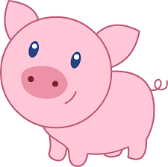
Your Polka Pig

